# i

|  |  |  |
| --- | --- | --- |
|  | Coordinates | Frequencies |
| F2 | -3.08 | 2254 |
| F1 | 1.828 |  |

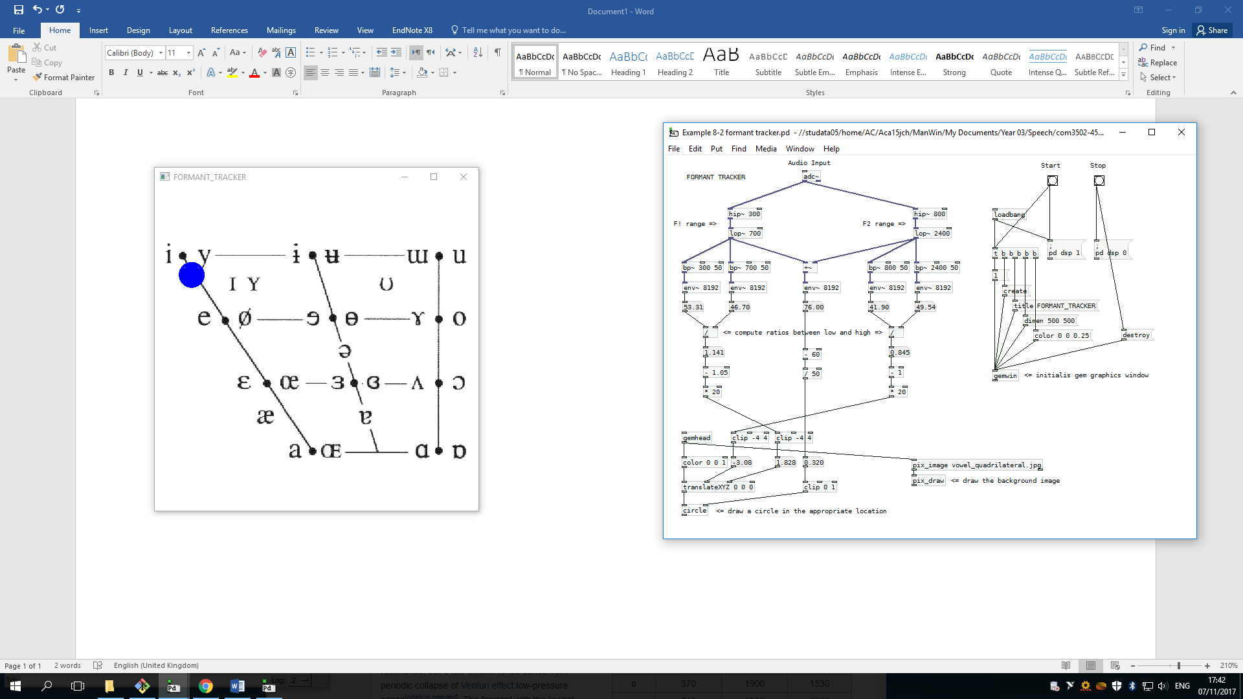

# u

|  |  |  |
| --- | --- | --- |
|  | Coordinates | Frequencies |
| F2 | 3.216 | 824.7 |
| F1 | 1.76 | 337.7 |

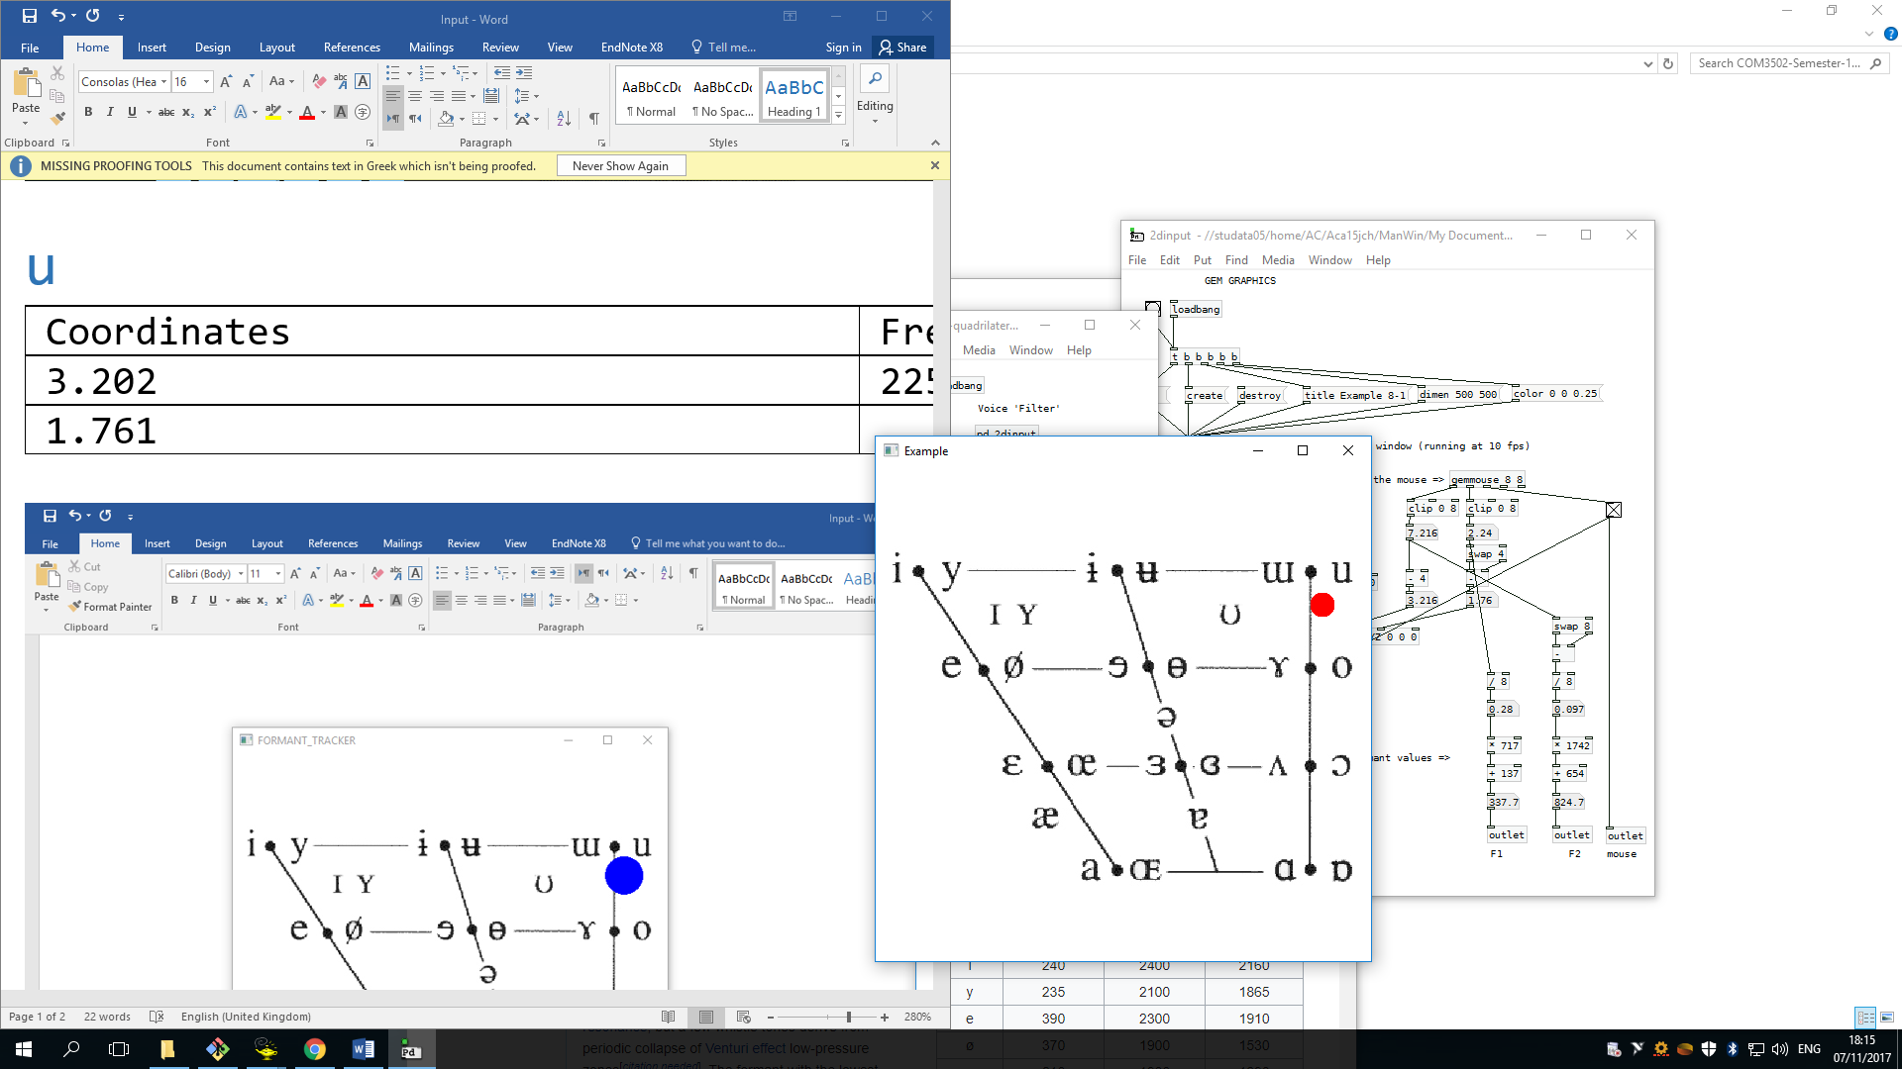

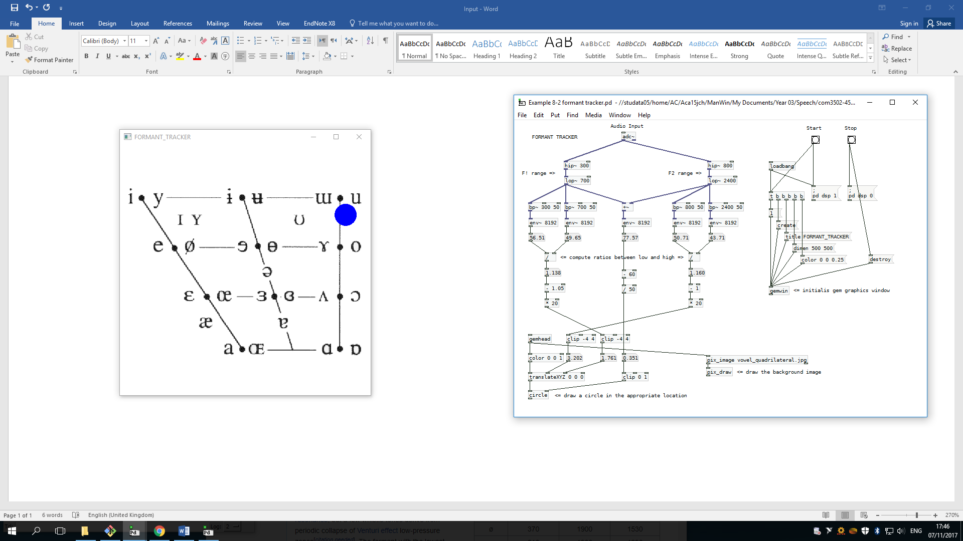

# a

x: 0.22

y: -2.15

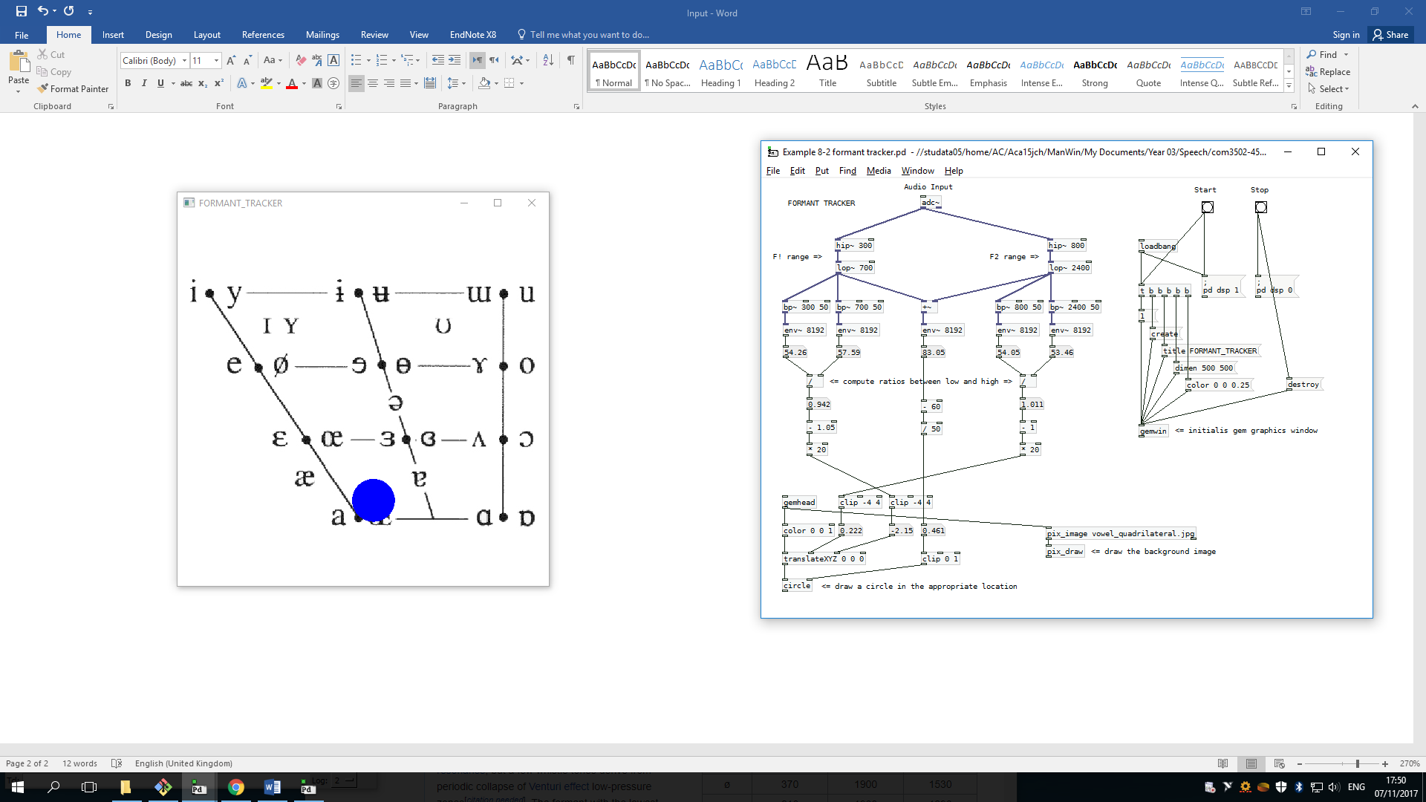

# α

x: 3.589

y: -2.61

